Pandas CRUD Operations
Pandas allows easy Create, Read, Update and Delete operations on data stored in CSV files, making it practical for real world datasets. It is known as CRUD Oprations.
- Create: Create and save a DataFrame as a CSV file
- Read: Load data from a CSV file
- Update: Modify values or add new columns
- Delete: Remove rows or columns
import pandas as pd
data = {"Name": ["A", "B", "C"], "Age": [20, 21, 22]}df = pd.DataFrame(data)df.to_csv("data.csv", index=False)
df = pd.read_csv("data.csv")print("Read:\n", df)
df["Age"] = df["Age"] + 1df["City"] = ["Delhi", "Mumbai", "Pune"]print("\nUpdate:\n", df)
df = df.drop("City", axis=1) df = df.drop(0, axis=0) print("\nDelete:\n", df)
Output:
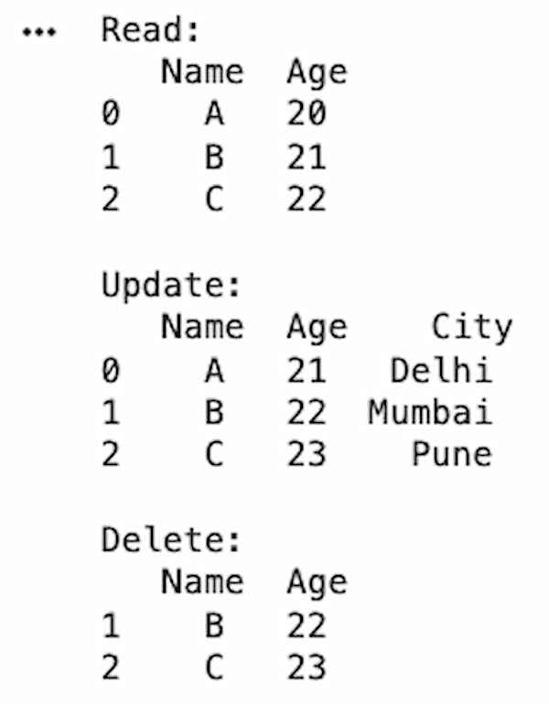CRUD Operations on a Dataset

Exploratory Data Analysis (EDA)

1. Data Inspection
Pandas provides quick methods to understand the structure, summary and content of a dataset. These functions help in exploring data before analysis.
- info(): Displays dataset structure, column names, data types and non null values
- describe(): Shows statistical summary like mean, min, max and standard deviation
- value_counts(): Counts frequency of unique values in a column
- head(): Displays first few rows of the dataset
- tail():Displays last few rows of the dataset
import pandas as pd
data = {
"Name": ["A", "B", "C", "A", "B"],
"Age": [20, 21, 22, 20, 21]}df = pd.DataFrame(data)
print("Info:")print(df.info())
print("\nDescribe:\n", df.describe())
print("\nValue Counts:\n", df["Name"].value_counts())
print("\nHead:\n", df.head())
print("\nTail:\n", df.tail())
Output:
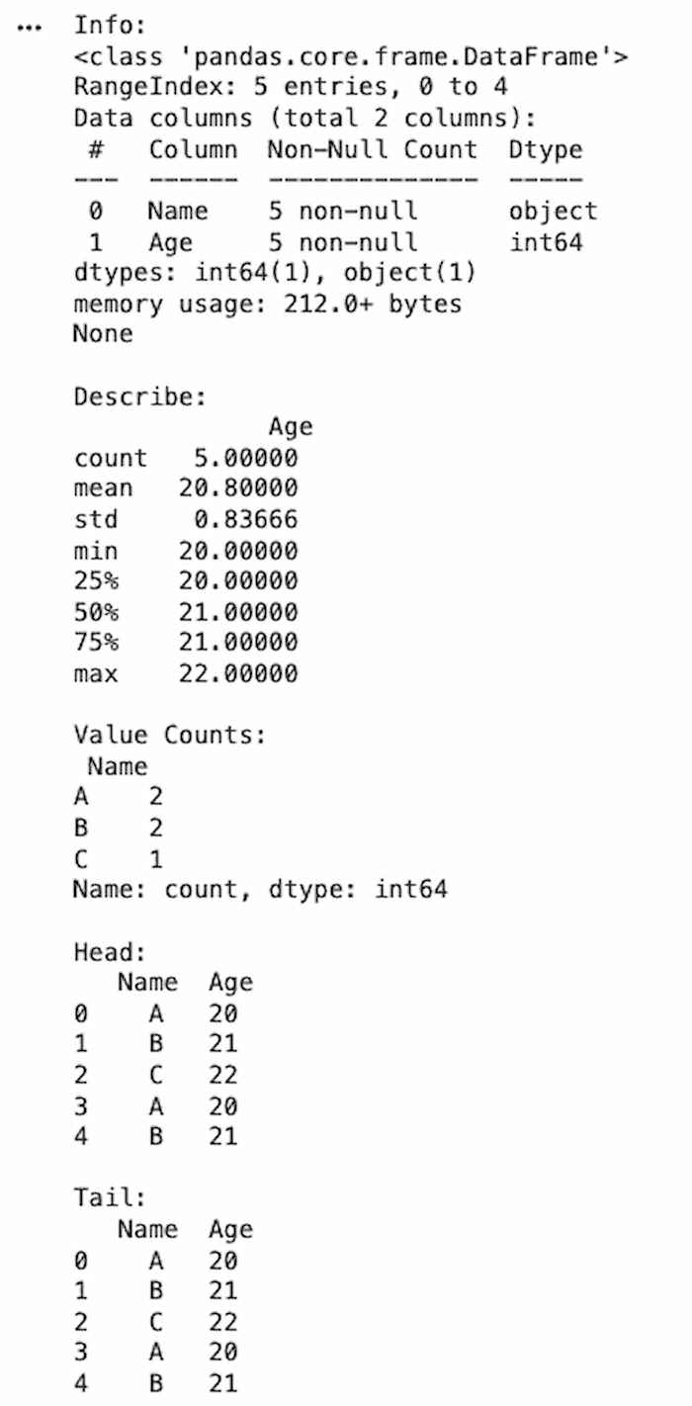Data Inspection

2. Data Manipulation in Pandas
Pandas provides multiple operations to efficiently select, organize and transform data for analysis.
Indexing and Selection
Indexing and Selection are used to access specific rows, columns or subsets of data.
import pandas as pd
df = pd.DataFrame({
"Name": ["A", "B", "C"],
"Age": [20, 21, 22]})
print(df["Name"]) print(df.iloc[0:2])
Output:
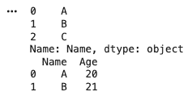Output
Grouping and Aggregation
Grouping and Aggregation Groups data based on a column and applies aggregate functions like mean, sum, etc.
import pandas as pd
df = pd.DataFrame({
"Name": ["A", "B", "A"],
"Marks": [80, 90, 85]})
print(df.groupby("Name")["Marks"].mean())
Output:
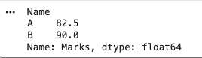Output
Merging and Joining
Merging and Joining combines multiple DataFrames based on common columns.
import pandas as pd
df1 = pd.DataFrame({"Name": ["A", "B"], "Age": [20, 21]})df2 = pd.DataFrame({"Name": ["A", "B"], "City": ["Delhi", "Mumbai"]})
print(pd.merge(df1, df2, on="Name"))
Output:
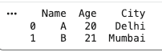Output
Sort
Sorts data based on column values.
import pandas as pd
df = pd.DataFrame({
"Name": ["A", "B", "C"],
"Marks": [85, 95, 90]})
print(df.sort_values(by="Marks", ascending=False))
Output:
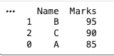Output
Filter
Filter selects data based on conditions.
import pandas as pd
df = pd.DataFrame({
"Name": ["A", "B", "C"],
"Marks": [85, 95, 90]})
print(df[df["Marks"] > 88])
Output:
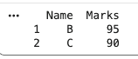Output
set_index
Sets a column as the index of the DataFrame.
import pandas as pd
df = pd.DataFrame({
"Name": ["A", "B", "C"],
"Marks": [85, 95, 90]})
print(df.set_index("Name"))
Output:
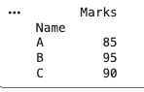Output
reset_index
Resets the index back to default numeric indexing.
import pandas as pd
df = pd.DataFrame({
"Name": ["A", "B", "C"],
"Marks": [85, 95, 90]}).set_index("Name")
print(df.reset_index())
Output:
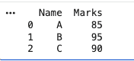Output

3. Working With Missing Data
Working with missing data is a key step in EDA to ensure data quality and accurate analysis. It involves identifying missing values and applying appropriate techniques to handle them without affecting results.
Checking Missing Data
Used to detect null values present in the dataset.
import pandas as pd
df = pd.DataFrame({
"Name": ["A", "B", "C"],
"Age": [20, None, 22]})
print(df.isnull()) print(df.isnull().sum())
Output:
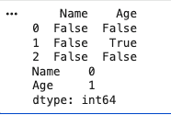Output
Dropping Missing Values
There are different methods to handle missing data based on requirements, here we just drop the missing values.
import pandas as pd
df = pd.DataFrame({
"Name": ["A", "B", "C"],
"Age": [20, None, 22]})
print(df.dropna())
df["Age"].fillna(df["Age"].mean(), inplace=True)print(df)
Output:
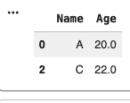Output

4. Checking and Handling Duplicate Values
Duplicate values can lead to incorrect analysis and biased results. Identifying and removing duplicates is an important step in data cleaning during EDA.
Checking Duplicate Values
Used to detect duplicate rows in the dataset.
import pandas as pd
df = pd.DataFrame({
"Name": ["A", "B", "A", "C"],
"Age": [20, 21, 20, 22]})
print(df.duplicated()) print(df.duplicated().sum())
Output:
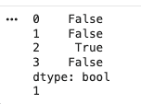Output
Handling Duplicate Values
Remove duplicate rows to clean the dataset.
import pandas as pd
df = pd.DataFrame({
"Name": ["A", "B", "A", "C"],
"Age": [20, 21, 20, 22]})
df_clean = df.drop_duplicates()print(df_clean)
Output:
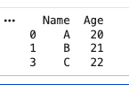Output

5. Outlier Detection and Handling
Outliers are extreme values that differ significantly from other data points. Detecting and handling them is important to improve data quality and model performance during EDA.
IQR (Interquartile Range) Method
Outliers are values below Q1 - 1.5 IQR or above Q3 + 1.5 IQR.
import pandas as pd
df = pd.DataFrame({
"Values": [10, 12, 14, 15, 100]})
Q1 = df["Values"].quantile(0.25)Q3 = df["Values"].quantile(0.75)IQR = Q3 - Q1
outliers = df[(df["Values"] < Q1 - 1.5*IQR) | (df["Values"] > Q3 + 1.5*IQR)]print("Outliers:\n", outliers)
Output:
